**BookHeaven Online Bookstore Project Documentation**

Welcome to BookHeaven, your one-stop online bookstore. This guide will walk you through the various pages and functionalities of the BookHeaven website, providing instructions and descriptions to help you make the most of your experience.

**Page 1: Sign-Up Page**

**Description:** The sign-up page is where new users can create an account on BookHeaven.

**Instructions:**

1. **User Name:** Enter your desired username (no spaces allowed).
2. **Full Name:** Enter your full name.
3. **Email:** Enter your email address.
4. **Phone:** Enter your phone number (10-digit mobile number).
5. **Password:** Enter a password (at least 8 characters long).
6. Click the **Sign Up** button to create your account.
7. If you already have an account, click **Sign in** to go to the sign-in page.

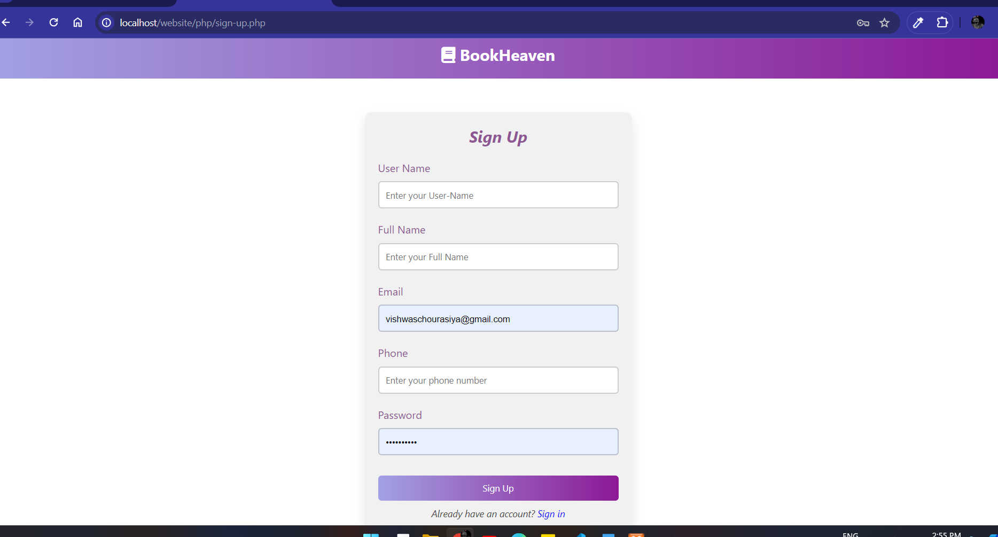

**Page 2: Sign-In Page**

**Description:** The sign-in page allows existing users to log in to their BookHeaven account.

**Instructions:**

1. **Username:** Enter your registered email address.
2. **Password:** Enter your password.
3. Optionally, check **remember me** to stay logged in on this device.
4. Click the **sign in** button to log in.
5. If you forgot your password, click **click here** to go to the password retrieval page.
6. If you don't have an account, click **create one** to go to the sign-up page.

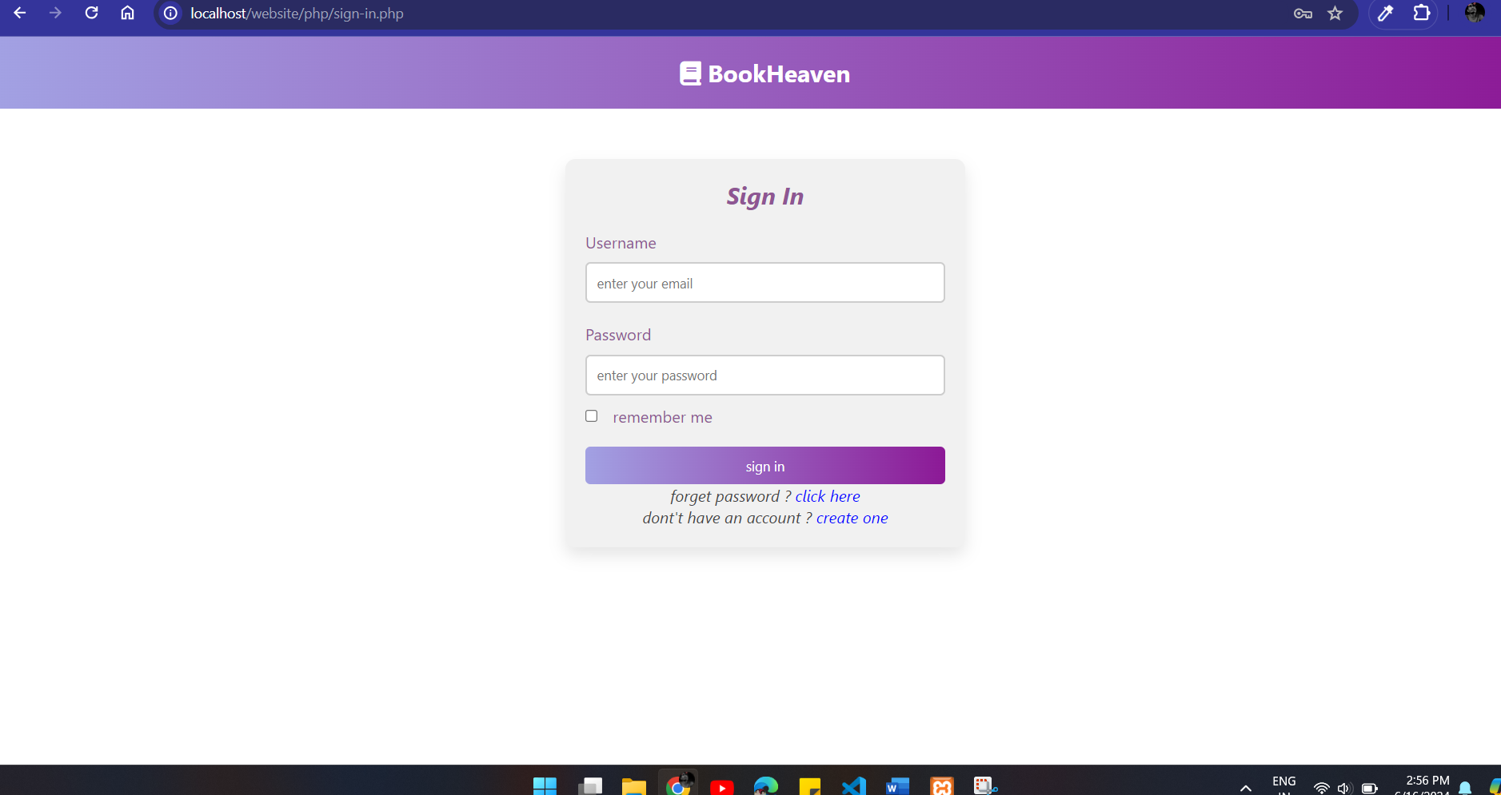

**Page 3: Forget Password Page**

**Description:** The forget password page allows users to retrieve their password if they have forgotten it.

**Instructions:**

1. **Email:** Enter your registered email address.
2. Click the **Submit** button to retrieve your password.
3. If you remember your password, click **Sign in** to go to the sign-in page.

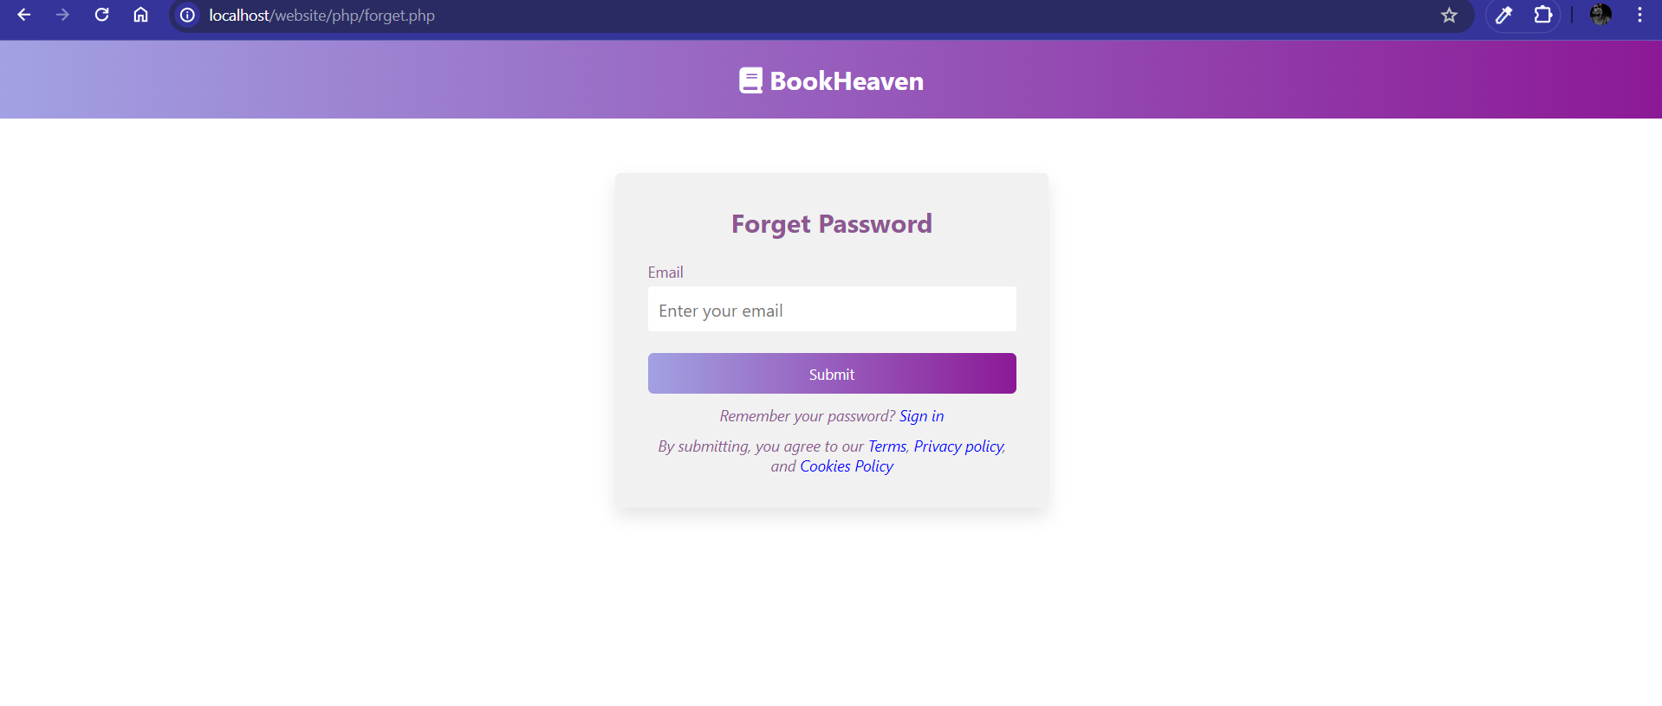

**Page 4: Home Page of BookHeaven**

**Description:** The home page is the main landing page of BookHeaven, showcasing promotions and featured books.

**Features:**

1. **Header:** Contains the BookHeaven logo, search bar, and user icons (favorites, cart, profile).
2. **Navigation Bar:** Links to Home, Featured, Arrivals, Reviews, and Blogs.
3. **Promotional Banner:** Highlights current promotions (e.g., up to 75% off).
4. **Book Slider:** Displays featured books in a carousel format.

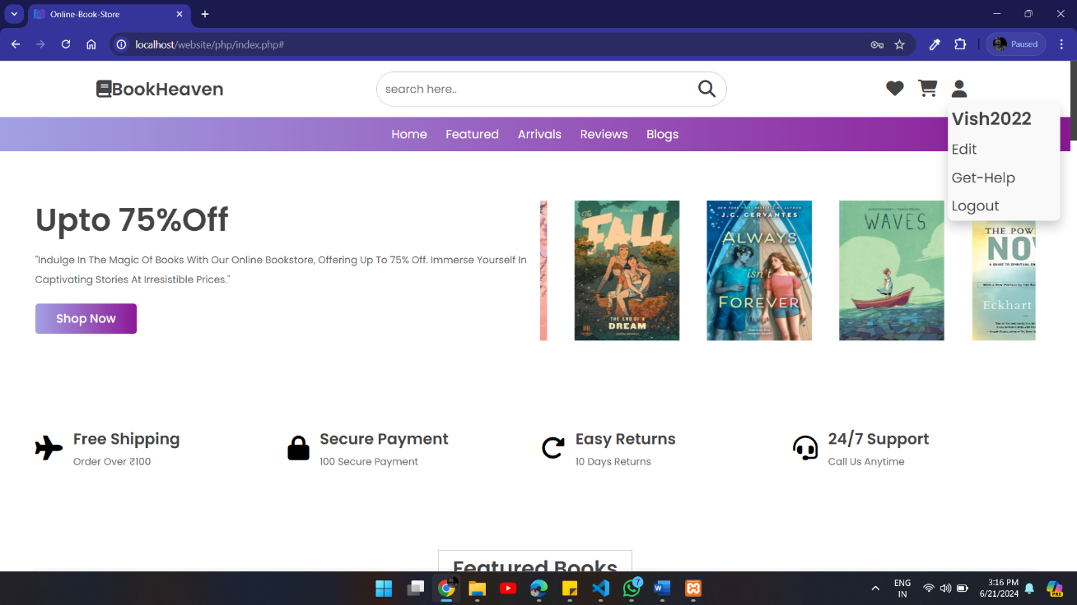

**Page 5: Featured Books Page**

**Description:** This page showcases a selection of featured books available on BookHeaven.

**Features:**

1. **Book Listings:** Each book is displayed with an image, title, price, and an "Add to Cart" button.
2. **Book Details:** Users can click on a book to view more details or add it to their cart.

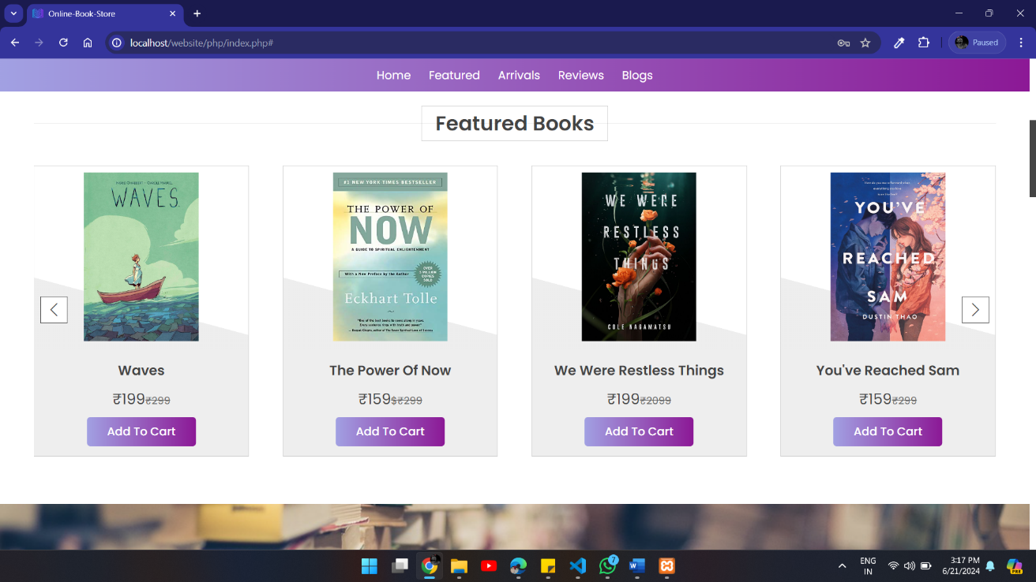

**Page 6: New Arrivals Page**

**Description:** This page displays the latest books added to BookHeaven.

**Features:**

1. **Book Listings:** Each new arrival is displayed with an image, title, price, and an "Add to Cart" button.
2. **Book Details:** Users can click on a book to view more details or add it to their cart.

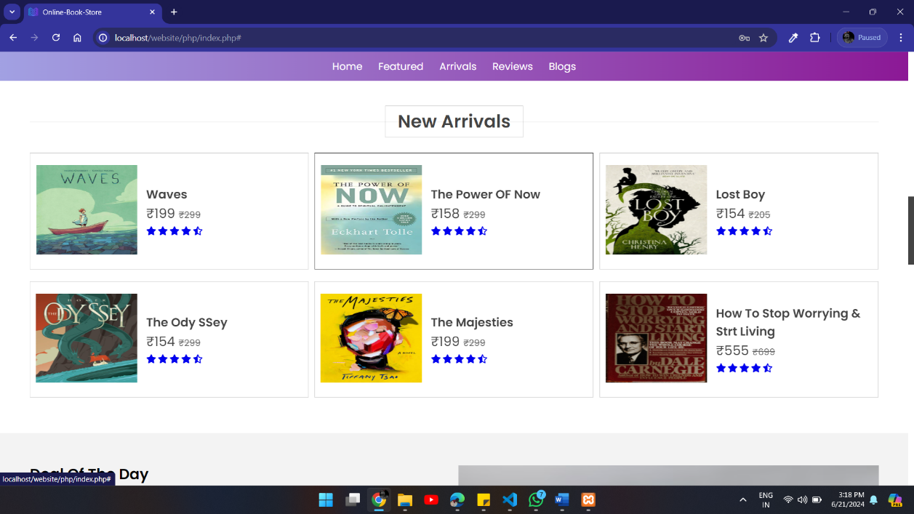

**Page 7: Reviews Page**

**Description:** This page features reviews from clients who have purchased books from BookHeaven.

**Features:**

1. **Review Listings:** Each review is displayed with the reviewer's name, image, rating, and review text.
2. **Star Ratings:** Visual representation of the rating given by the reviewer.

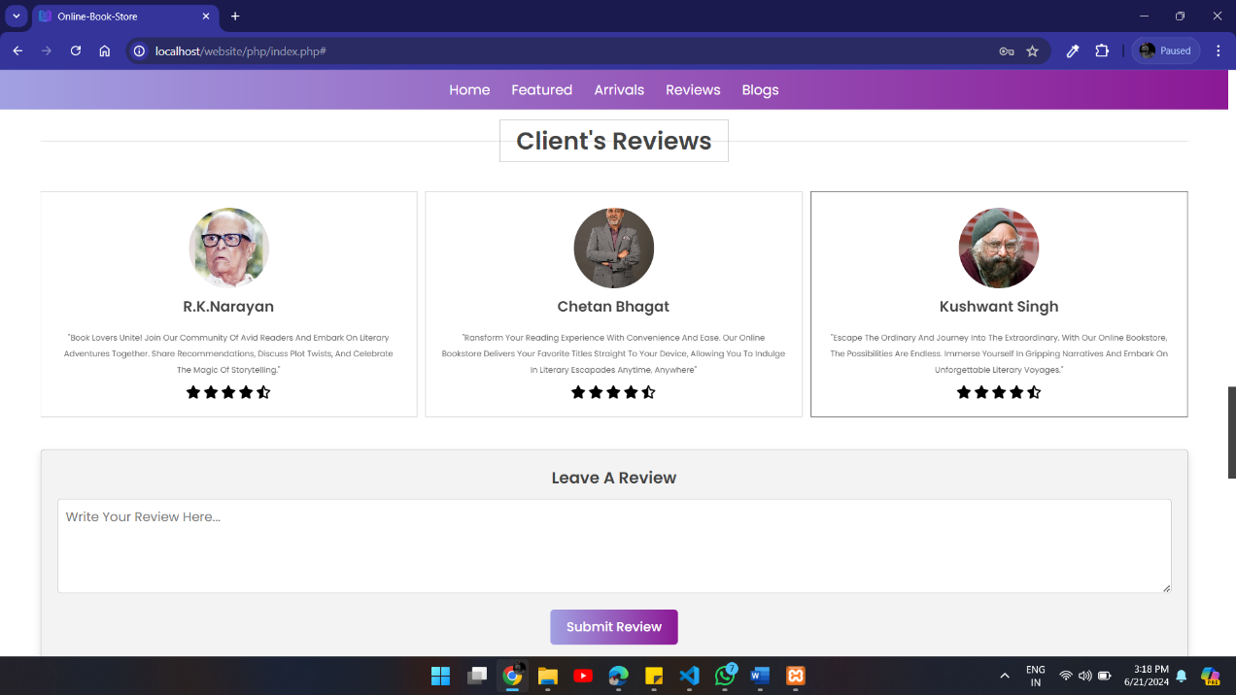

**Page 8: Blogs Page**

**Description:** This page contains blog posts related to books, reading habits, and literary discussions.

**Features:**

1. **Blog Listings:** Each blog post is displayed with an image, title, and a short snippet of the content.
2. **Read More:** Users can click on a blog post to read the full content.

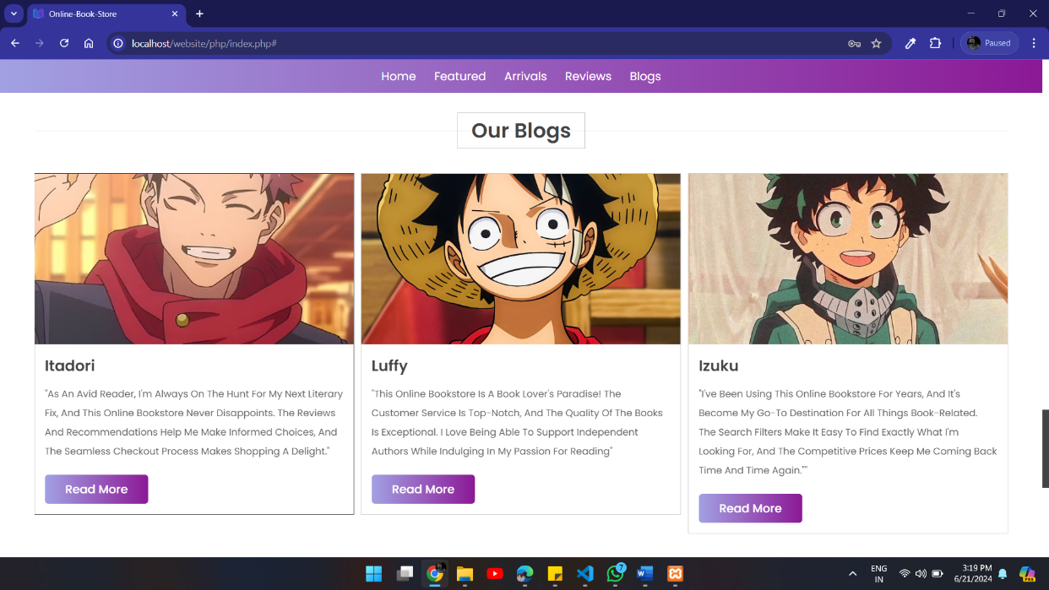

#### Page 12: Footer Page

**Description:** The footer page provides additional navigation links, contact information, and social media links.

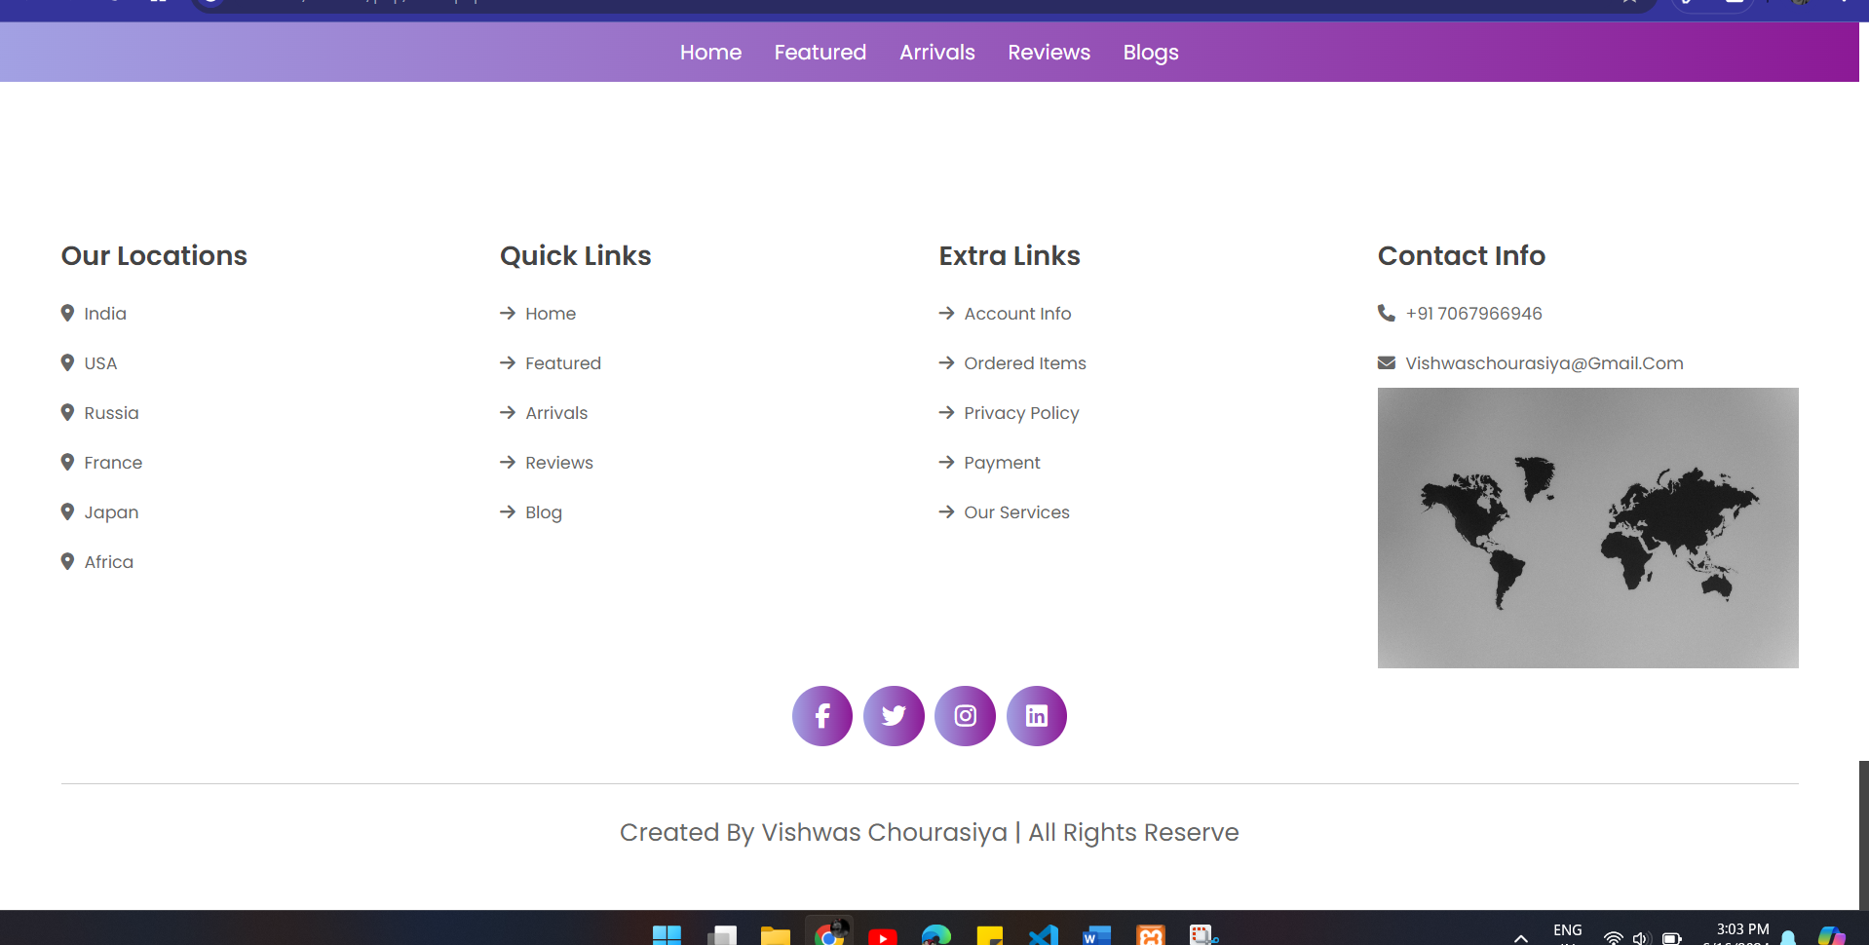

**Page 9: User Dropdown and Edit Profile**

**Description:** The user dropdown menu allows users to access their profile, get help, and log out. The edit profile page lets users update their personal information.

**Instructions:**

1. **User Dropdown:** Click the profile icon in the header to open the dropdown menu.
   * **Edit Profile:** Click to go to the edit profile page and update your username, full name, phone number, and password.
   * **Get Help:** Click to go to the help page for assistance.
   * **Logout:** Click to log out of your account.
2. **Edit Profile:** Update your information and click **Update Profile** to save changes.

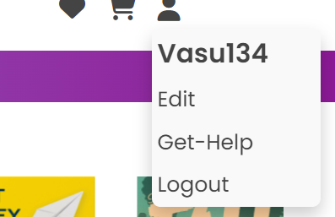

**Page 10: Cart Page**

**Description:** The cart page displays all the books added to your cart for purchase.

**Features:**

1. **Book Listings:** Each book in the cart is displayed with an image, title, price, and quantity.
2. **Total Amount:** Displays the total amount for the books in the cart.
3. **Checkout:** Button to proceed to the checkout process.

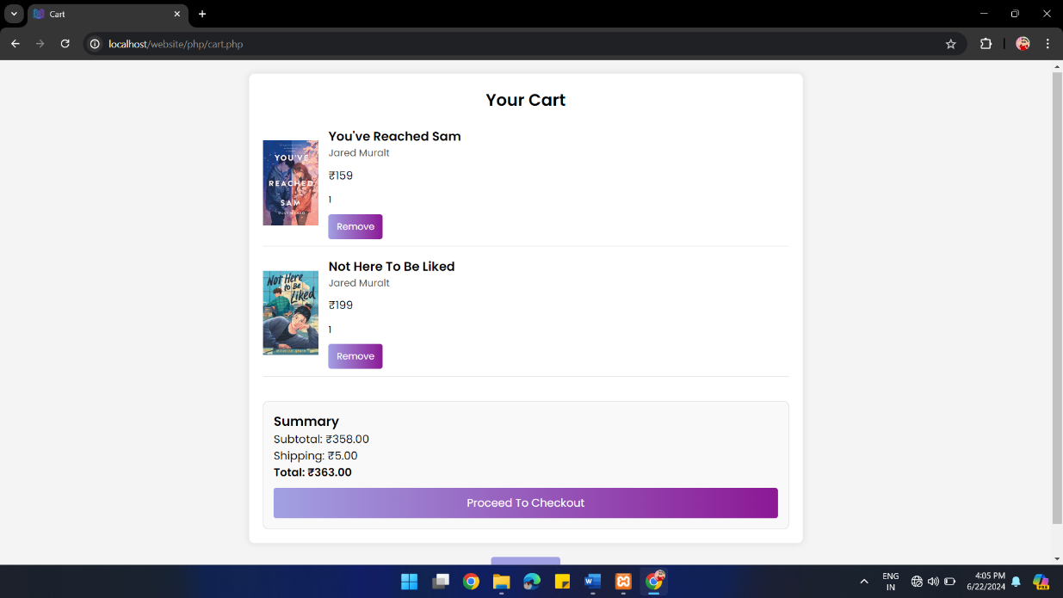

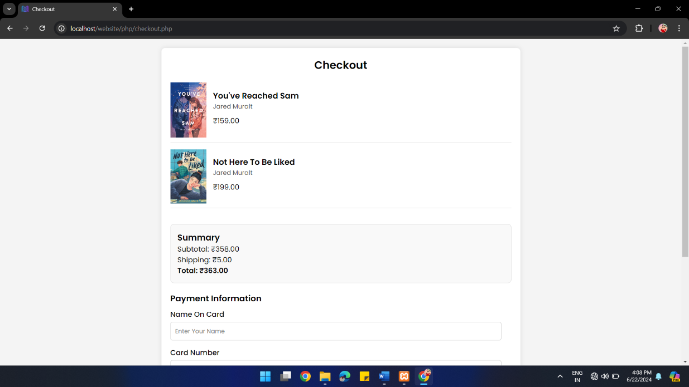

**11: Favourites Page**

**Description:** The favourites page displays all the books you have marked as favourites.

**Features:**

1. **Book Listings:** Each favourite book is displayed with an image, title, and price.
2. **Remove from Favourites:** Option to remove a book from the favourites list.

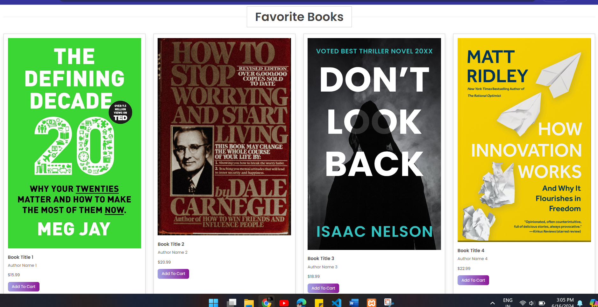

**Get Help Page**

**Description:** The help page provides assistance and answers to frequently asked questions.

**Features:**

1. **FAQs:** List of common questions and answers.
2. **Contact Information:** Details on how to contact customer support for further assistance.

This documentation provides an overview and instructions for navigating and using the various pages of the BookHeaven online bookstore. If you have any questions or need further assistance, please visit the help page or contact customer support. Enjoy your book shopping experience!

